Test Document for Ford OpenXC

Testing of OpenXC backend is provided via below two modes –

1. Via a cloud hosted web portal <http://54.179.173.108:8080/OpenXCFrontEnd/>
2. Via an Android App (APK)

Details on how testing could be carried out through these two modes are given in below sections.

# Testing via Web Portal

**Prerequisites:**

1. **Web browser**
2. **Internet connectivity with open internet access**

## Vehicle Registration Web service

**Method Name being tested:** *registerVehicle( )*

**Please follow below set of steps in sequence –**

1. Open the OpenXC test portal URL i.e. <http://54.179.173.108:8080/OpenXCFrontEnd/>

(This is a temporary URL, for testing, available only for 2 weeks).

1. Please input User Name as admin and password as admin.
2. After logging into the system, click on the second tab “Register Vehicle” which is meant for new vehicle registration with the system.
3. Vehicle registration form will be displayed on the page. Kindly fill all the mandatory fields and then click Submit button.
4. After successful registration, unique id will be created and then vehicle will be registered with the portal.
5. The **registration ID like 100029** will be displayed on screen

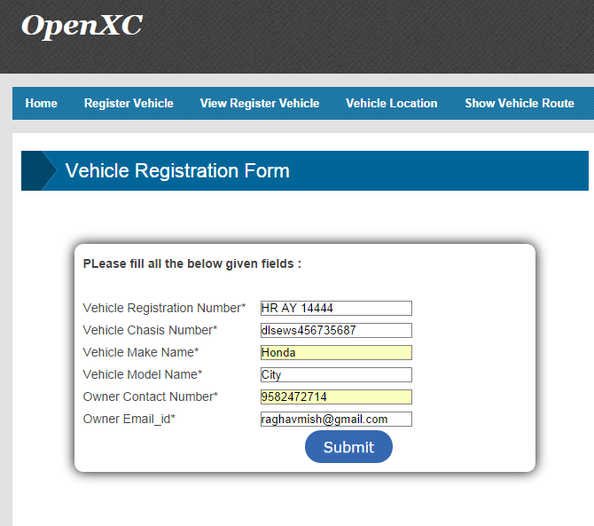

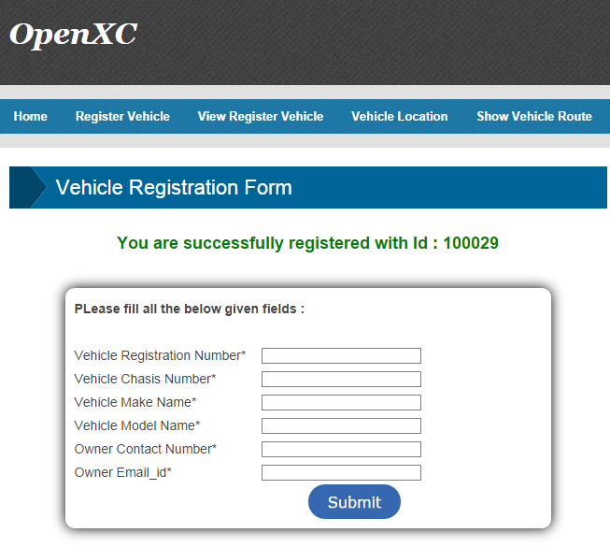

## View Registered Vehicles List Web Service

**Method Name being tested:** *getRegisteredVehicleList()*

1. There is a third tab named “View Register vehicle” which can be used to see list of all the registered vehicles with the portal.
2. “View Register vehicle” tab need to be clicked in order to view list of all the registered vehicles.
3. After clicking on the tab, list will be populated on the portal.

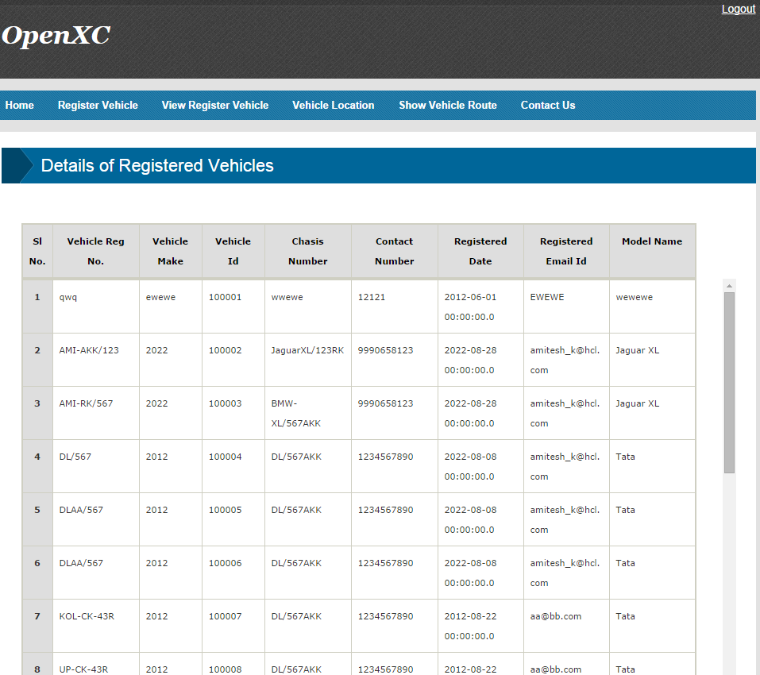

## Vehicle Location web service (Single Vehicle)

**Method Name being tested:** *getVehicleCurrentLocation* ()

1. Fourth tab is “Vehicle location”. In this part there are two different features. One is to find out current location of particular vehicle and second is to track current locations of all registered vehicles.
2. On clicking “Vehicle Location” tab two sections will be displayed one for tracking single vehicle location and below this, there will be section to get all vehicles current locations.
3. Single vehicle location can be tracked by providing Vehicle registration number and clicking submit, after this car location related parameters will be displayed in tabular format.

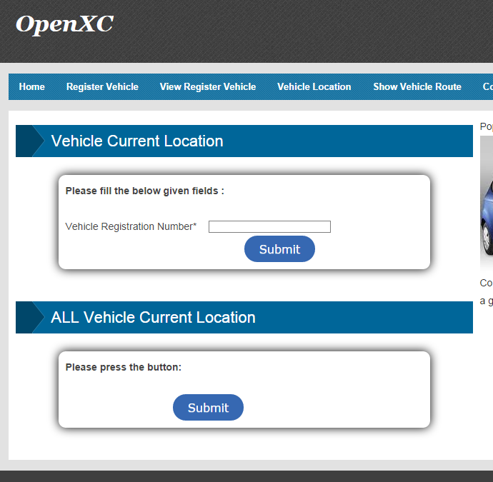

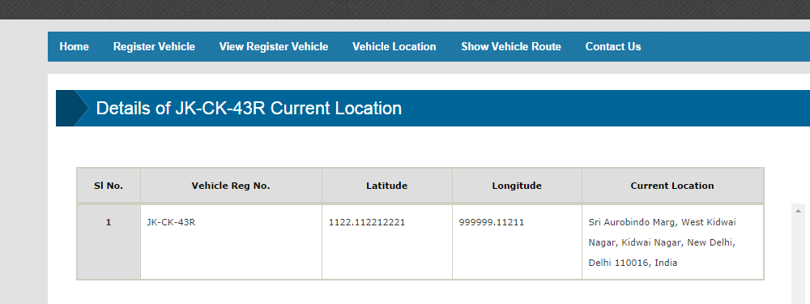

## Vehicle Location web service (All Vehicles)

**Method Name being tested:** *getAllVechicleCurrentLocation*()

1. Similarly in the Fourth tab for getting Vehicle Location, on clicking “Vehicle Location” tab two sections will be displayed one for tracking single vehicle location and below this, there will be section to get all vehicles current locations.
2. All vehicles location can be tracked by clicking submit button under “All Vehicle Current location”, after this car location related parameters will be displayed in tabular format for all vehicles.

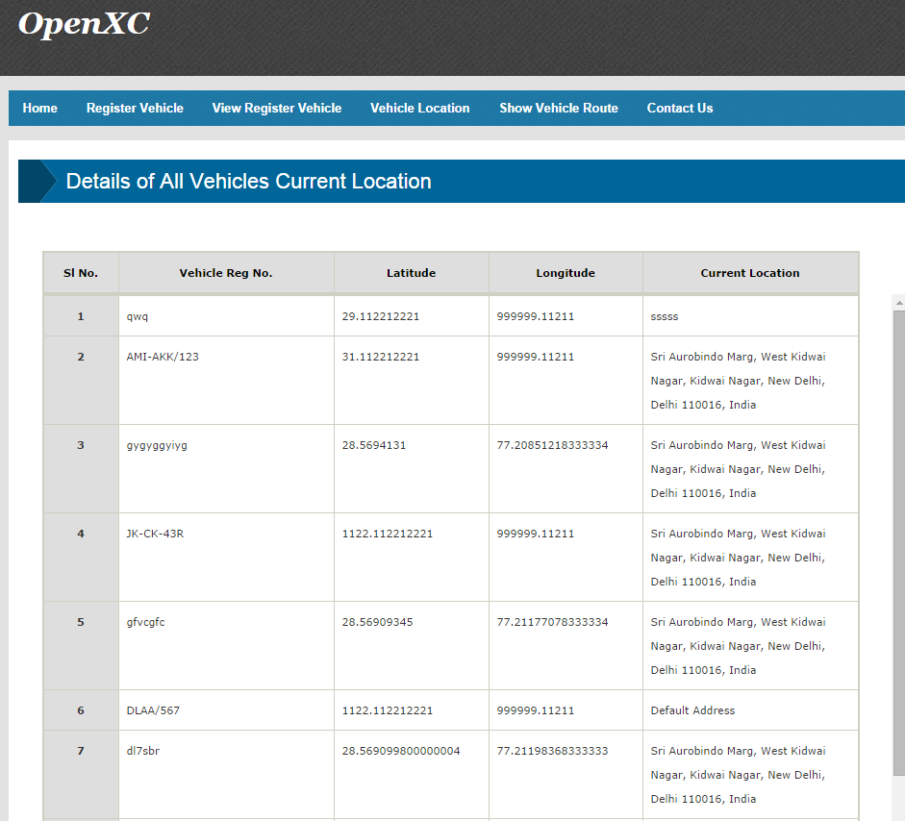

## Vehicle Route Web Service

**Method Name being tested:** *showRoute*()

1. Fifth tab on the panel named “Show vehicle route” is used to track a traversed route by a vehicle.
2. After clicking the tab, it will ask for Vehicle registration number in which we need to fill the registration number details and click submit button.
3. Doing this we can be able to see tabular format data of traversed route by a vehicle.

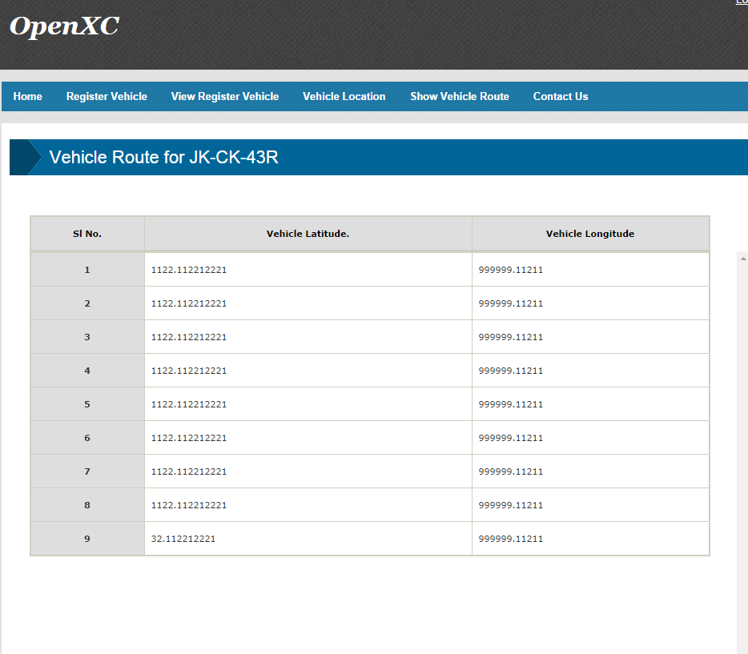

# Testing via Mobile Application

## Application installation & pre-set up

1. Install the ‘**ConnectedCarClientApp.apk’** on Android Tab using with a normal installation process.
2. **Device prerequisite** 
   1. **Android version should be 2.3 or above**
   2. **Phone Screen Size 5” or larger**
   3. **Android Tab of 7” or larger**
3. Setting to be done on device
   1. Enable the Internet connectivity on the device via Wi-Fi / Mobile SIM (open internet required)

## Individual Methods testing

### Vehicle Registration Web Service

**Method Name being tested:** *registerVehicle( )*

1. Run the application by clicking the app icon ‘**ConnectedCarClientApp'** icon.
2. App Starts and shows a registration screen.
3. Here registerVehicle() method is called.
4. Register vehicle by entering all the information (e.g. Vehicle Reg. no. , Model, Make, Chassis number, Email, Contact Number)
5. Upon successful registration, server gives us a unique Registration id, which will be displayed on the following screen on top left.

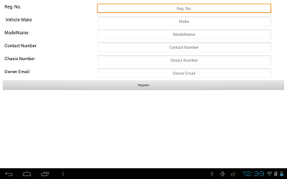

### Data Upload Web Service

**Method Name being tested:** *uploadVehicleData*()

1. Next Screen shows data uploading (ex- longitude, latitude, speed, timestamp) and displays the vehicle data stream on screen
2. Data will start uploading every 30 seconds to the cloud server.
3. Counting of data upload shows on Upper Right corner in Green Text.

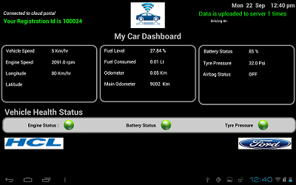

### Get Vehicle Location Web Service

**Method Name being tested:** *getVehicleCurrentLocation*()

1. To get location first upload the Registration Number on server that happens internally.
2. Then we get the Last Known location of moving vehicle from Server.
3. Data is uploading on every 30 seconds.
4. We can see the location on the upper right corner in Driving At section.

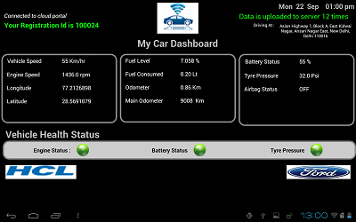

**~~ End of doc ~~**